SOCIAL SPARK CHAT APPLICATION

Project Documentation

Student Name: Miehleketo Hlayiseko Magagula
Course: Higher Certificate in Mobile Application and Web Development

Institution: Rosebank College
Year: 2026

Overview
Social Spark Chat is a simple Android application developed using Kotlin in Android Studio.
The purpose of the application is to help users maintain social connections during busy days by suggesting
small social interactions based on the time of day entered by the user.
The application provides these suggestions in a chatbot-style interface, making the interaction feel
natural and engaging. The user enters a time of day such as Morning, Afternoon, or Night, and the
application responds with a social interaction suggestion.
This project demonstrates the use of Kotlin programming, conditional logic (if statements), Android
user interface design, logging, error handling, GitHub version control, and automated building using
GitHub Actions.

Purpose of the Application
The main purpose of the Social Spark Chat app is to help people stay socially
connected even when they are busy. Many people struggle to maintain regular communication with friends,
family members, and colleagues due to busy schedules.
This application simplifies the process by providing small social interaction ideas that can be completed
quickly. These suggestions are based on the time of day provided by the user.
The application also demonstrates the implementation of basic programming logic in a real-world Android application.

Features
• Chatbot Style Interface – The application interacts with the user in a conversation format.
• User Input – Users can type the time of day such as Morning, Mid-morning, Afternoon, Snack time, Dinner, or Night.
• Social Suggestions – The app suggests different social interactions depending on the time entered.
• Reset Function – A reset button allows the user to restart the conversation and clear the chat history.
• Error Handling – If the user enters an invalid time, the application displays a helpful message.
• Logging – Logging is used to track user input and debugging information during development.

Application Logic
The application uses conditional statements in Kotlin to determine which suggestion
should be displayed.
logic:
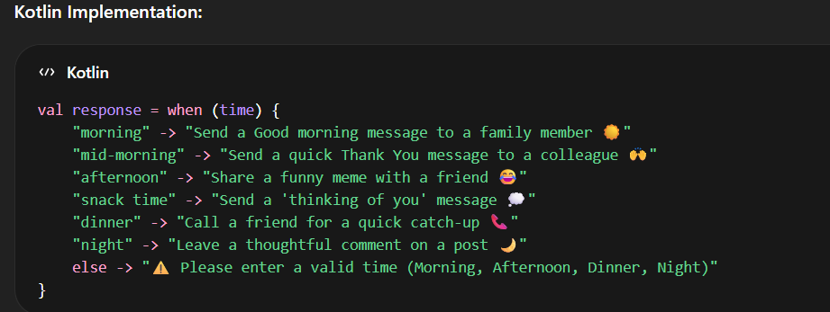
If the input does not match any expected value, the application returns an error message.

User Interface Design
The user interface was designed to be simple, engaging, and easy to use.
The layout includes:
• Application title
• Chat display area
• Input field for the time of day
• Send button
• Reset button
The chat-style interaction improves usability and makes the app feel interactive.

Error Handling
The application includes error handling to improve user experience.
Examples include:
• Preventing empty input
• Displaying messages when invalid input is entered
• Guiding users to enter valid times of day
This ensures that the application behaves reliably and helps users correct mistakes.

Logging
Logging is implemented using Android's logging system to track application behaviour.
Logs help track:
• User input
• Invalid entries
• Reset actions
Logs are displayed in Android Studio's Logcat for debugging and testing.

Version Control Using GitHub
Version control for this project is managed using GitHub.
GitHub allows developers to:
• Store project code online
• Track changes to files
• Maintain a project history
• Share and collaborate with others
The repository includes the Android source code, layout files, documentation, screenshots, and workflow files.

GitHub Actions (Automated Build)
GitHub Actions is used to automatically build the Android application
whenever code is pushed to the repository.
The workflow:
1. Checks out the repository
2. Sets up the Java environment
3. Runs the Gradle build
4. Confirms the application builds successfully
This ensures the application works across different environments.

Testing
Manual testing was performed to ensure the application functions correctly.
Testing included:
• Entering valid times of day
• Entering invalid values
• Testing the reset function
• Checking chatbot responses
• Monitoring logs in Logcat

Screenshots
such as:
• Home screen
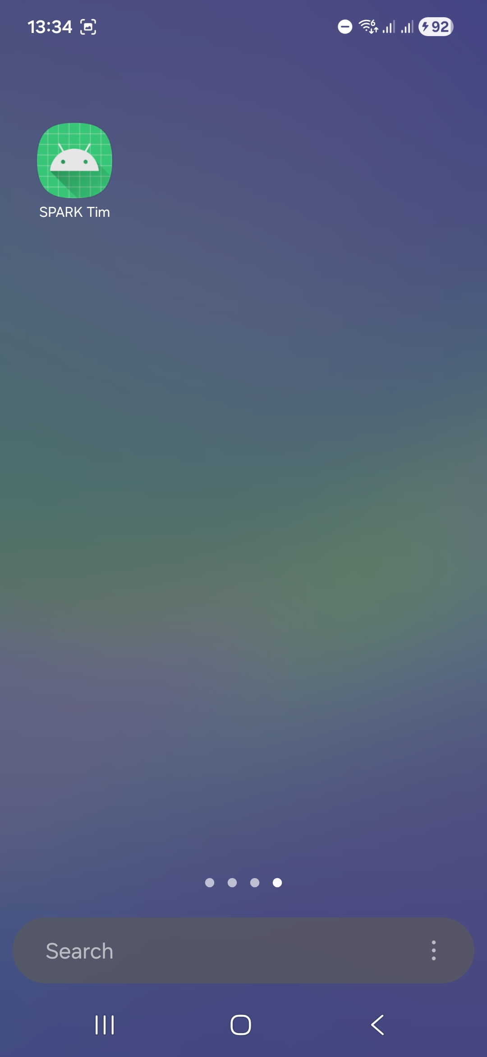
• Chat interaction
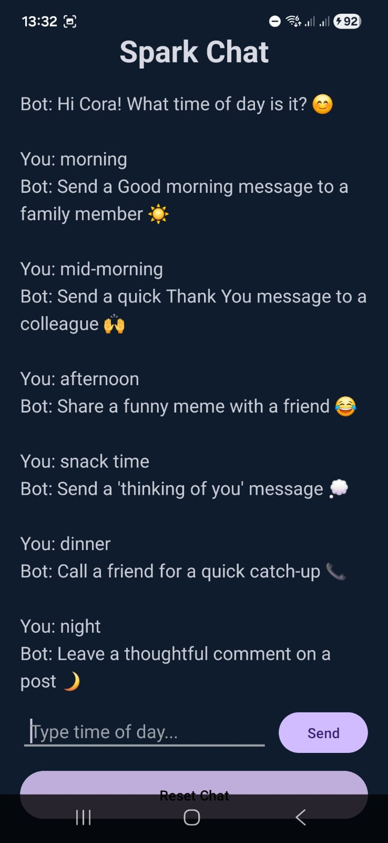
• Suggestion response
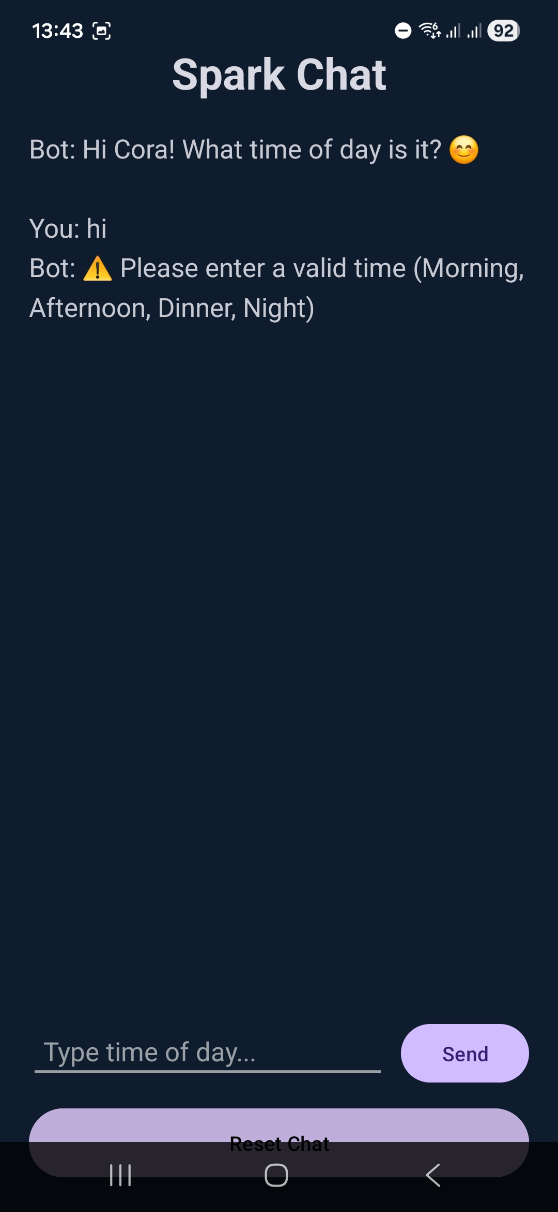
• Reset functionality
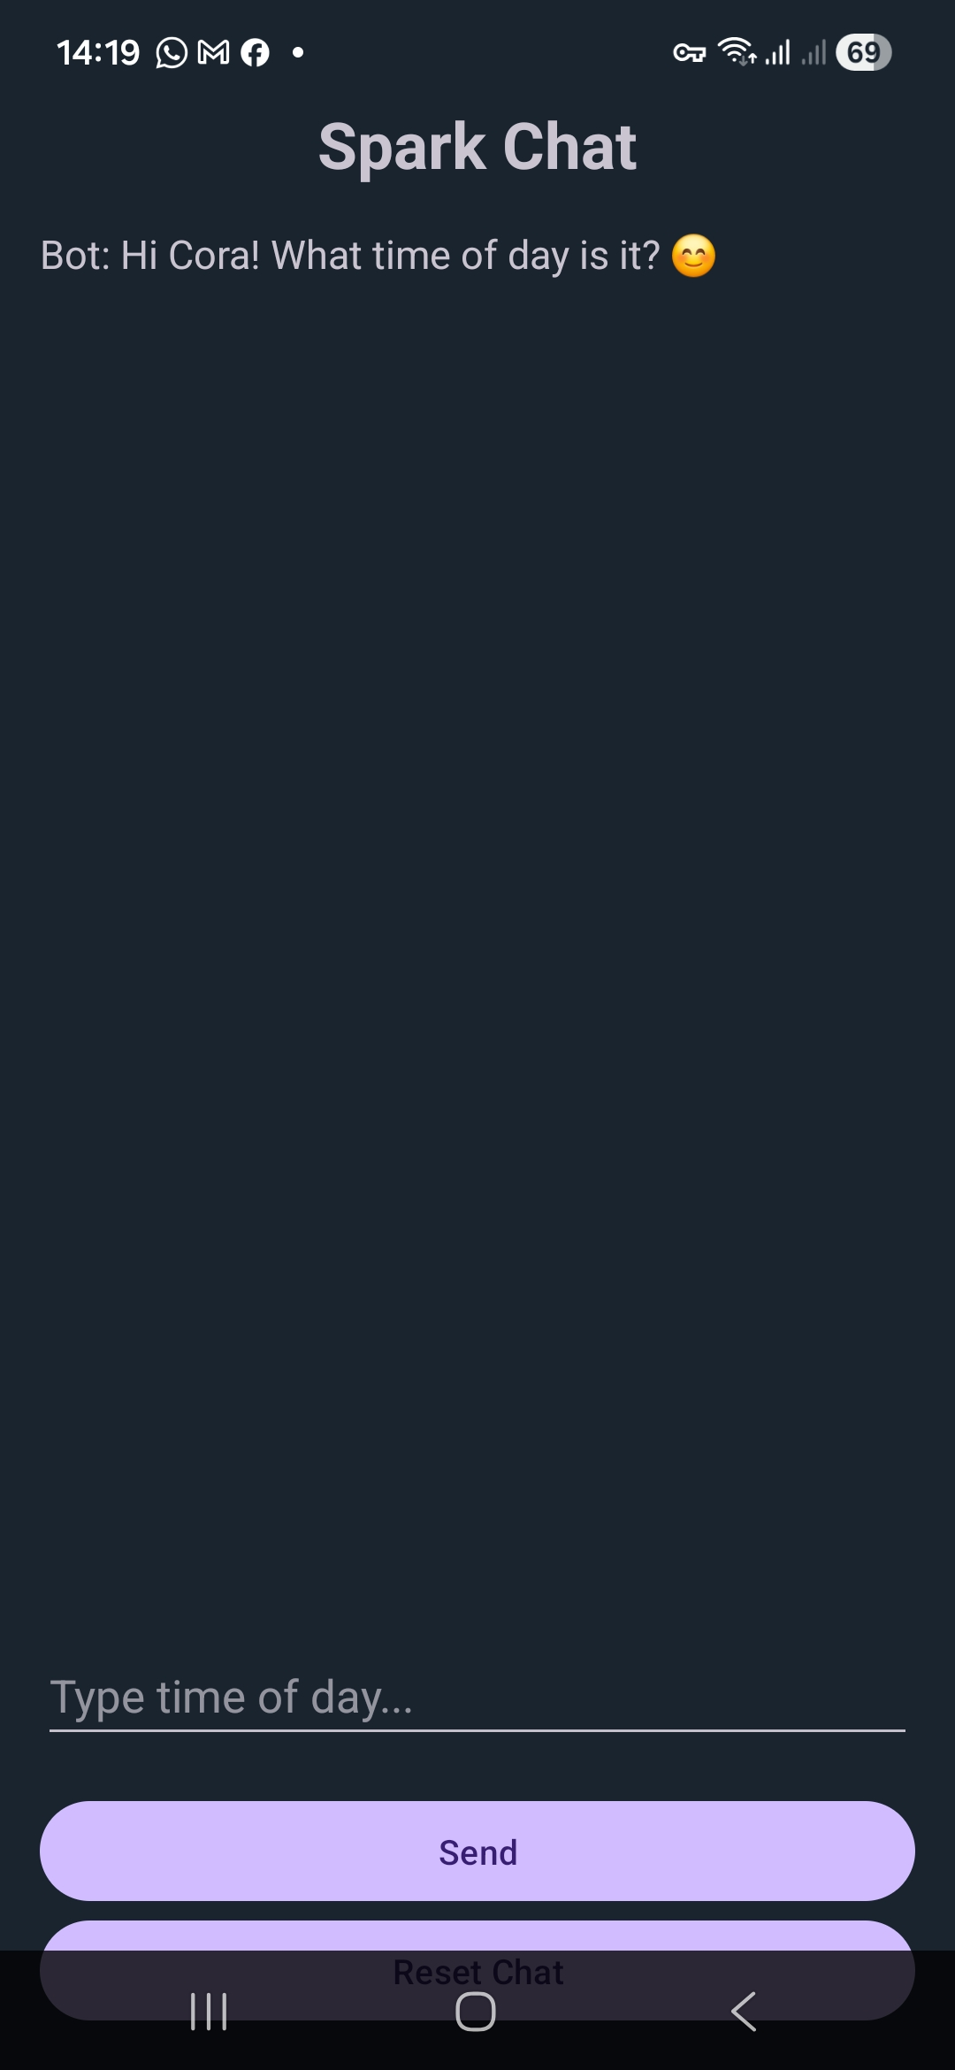

Video Demonstration
A video presentation demonstrating the functionality of the Social Spark Chat
application should be uploaded to YouTube as an unlisted video and linked here.
The video should demonstrate:
• Application interface
• User input and responses
• Reset function
• Code overview
• GitHub repository
• GitHub Actions workflow

Technologies Used
• Kotlin
• Android Studio
• XML Layouts
• Gradle Build System
• Git Version Control
• GitHub
• YouTube (for the demo video)

References
Android Developers, 2024. Android Developer Documentation. [online] Available at: https://developer.android.com [Accessed 30 Mar. 2026].
GitHub, 2024. GitHub Documentation. [online] Available at: https://docs.github.com [Accessed 30 Mar. 2026].
JetBrains, 2024. Kotlin Documentation. [online] Available at: https://kotlinlang.org/docs/home.html [Accessed 30 Mar. 2026].
Pressman, R. and Maxim, B., 2020. Software Engineering: A Practitioner’s Approach. 9th ed. New York: McGraw-Hill.

